**Lexar® Professional Workflow SD/microSD  
UHS-II Card Reader**

[Where to buy](https://americas.lexar.com/product/lexar-professional-workflow-sd-microsd-uhs-ii-card-reader/)

**Key Features:**

* Simultaneous Transfers
* Blazing-Fast UHS-II Transfer Speeds
* Stronger yet Lighter
* Works with Lexar Professional Workflow
* Ready, Right Out of the Box

[Features](https://americas.lexar.com/product/lexar-professional-workflow-sd-microsd-uhs-ii-card-reader/#feature-section)[Specifications](https://americas.lexar.com/product/lexar-professional-workflow-sd-microsd-uhs-ii-card-reader/#specifications)[Part Numbers](https://americas.lexar.com/product/lexar-professional-workflow-sd-microsd-uhs-ii-card-reader/#product-numbers)[Related products](https://americas.lexar.com/product/lexar-professional-workflow-sd-microsd-uhs-ii-card-reader/#related-products)

**Features**

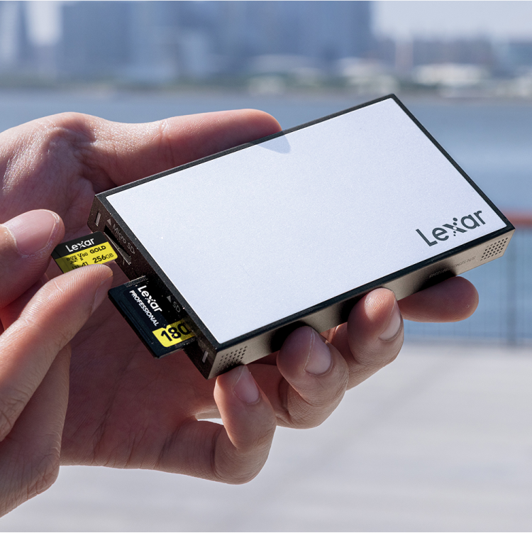

**Two-in-One Simultaneous Reader**

The Professional Workflow SD™/microSD™ UHS-II Card Reader lets you offload two cards simultaneously for an expedited workflow. It delivers up to 312MB/s transfer speed (per slot), features a special scratch-resistant aluminum finish, and includes a USB-C™ to USB-C cable and a USB-A adapter. It also comes with a worry-free 3-year warranty.

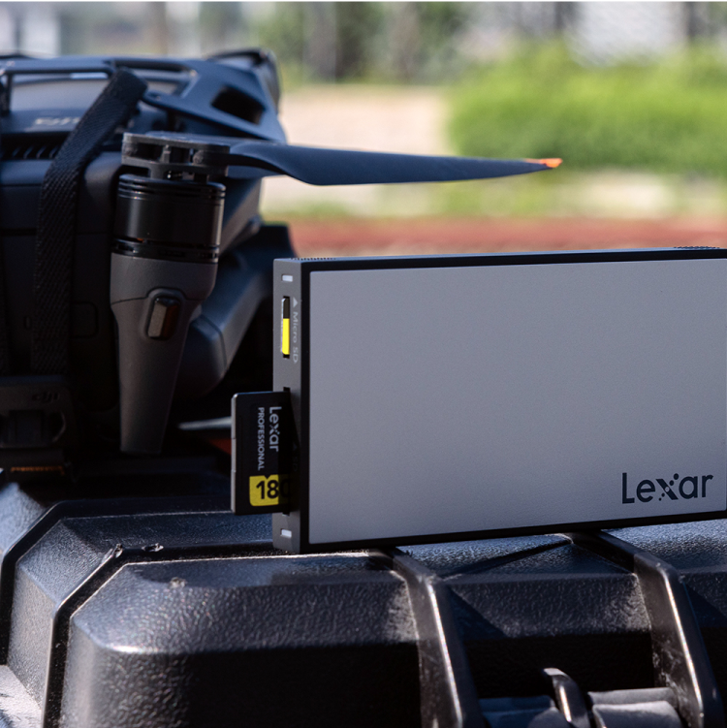

**Simultaneous Transfers**

SD™ and microSD™ card slots let you transfer content from DSLR and mirrorless cameras, drones, or action cameras simultaneously.

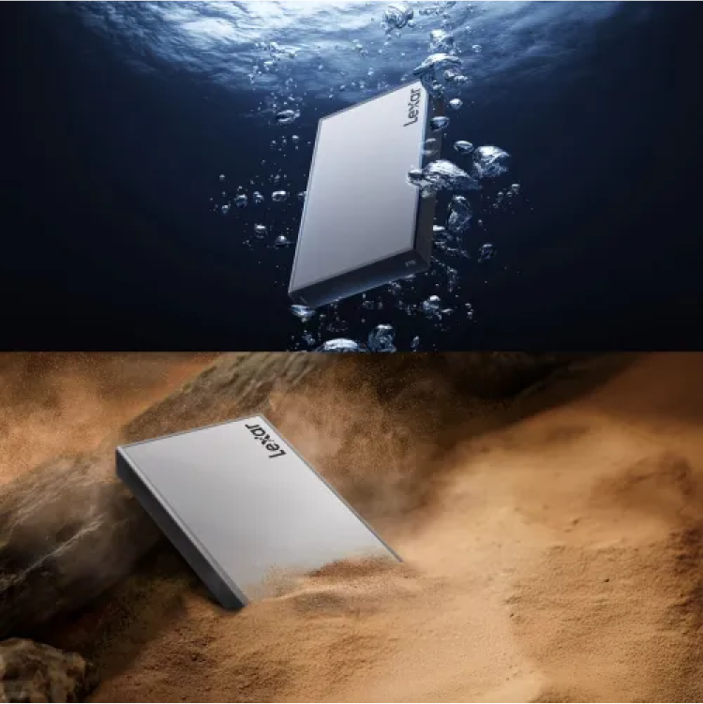

**Blazing-Fast UHS-II Transfer Speeds**

UHS-II technology delivers up to 312MB/s transfer speed per slot.

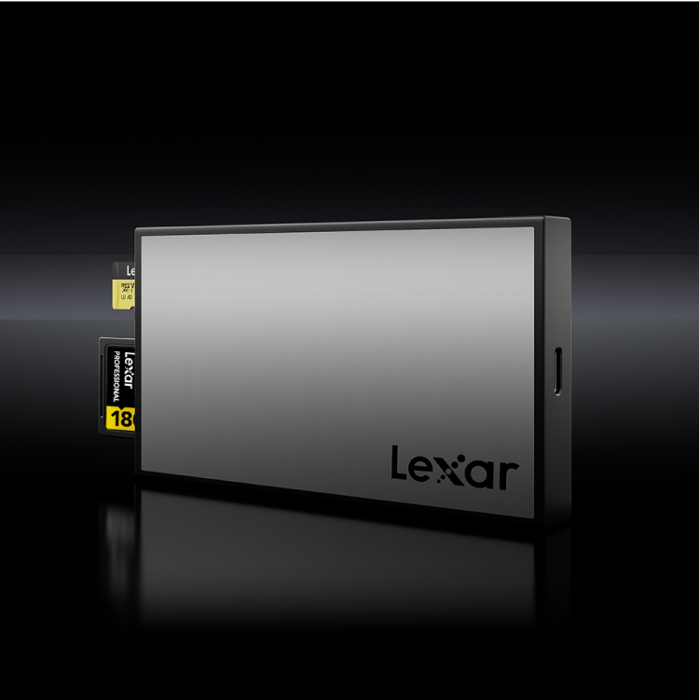

**Stronger yet Lighter**

The special aluminum finish offers better scratch-resistance while keeping the reader module light and convenient for travel.

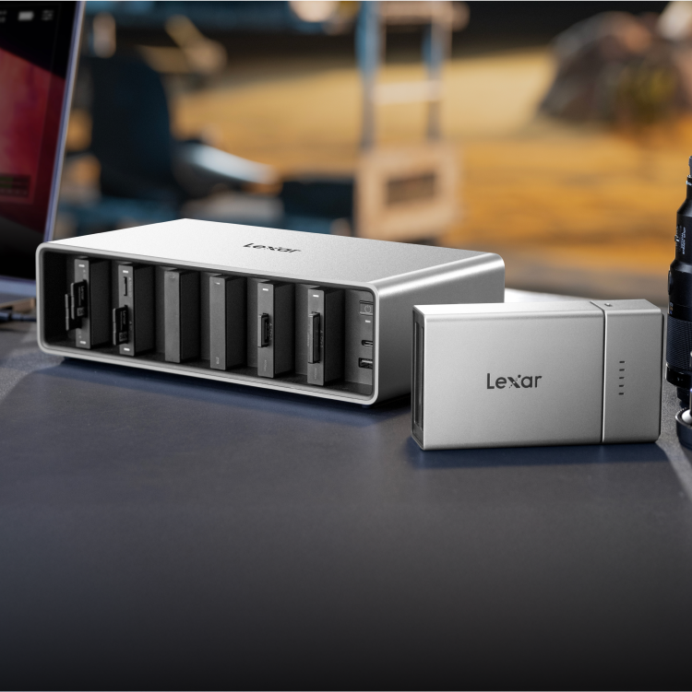

**Works with Lexar Professional Workflow and Workflow Go**

Add to a Lexar Professional Workflow Docking Station to create your customized post-production solution.



**Ready, Right Out of the Box**

Includes a USB-C™ to USB-C cable, a USB-A adapter and a 3-year warranty.



**Rigorously Tested**

All Lexar products undergo extensive testing in the Lexar Quality Labs, facilities with thousands of different cameras and digital devices to ensure performance, quality, compatibility, and reliability.

**Specifications**

* Model

WF 710

* Interface

USB 3.2 Gen 2

* Operating Temperature

0° to 40°C (32°F to 104°F)

* Storage Temperature

-20° to 85°C (-4°F to 185°F)

* Weight

60g

* Dimensions (L x W x H)

103.4 x 57.7 x 12.0mm

* Systems Supported

Mac OS X 10.6+, Windows 11 / 10 / 8 / 7 / Vista / XP, Linux, USB2.0+

* Shock

1500G, duration 0.5ms, Half Sine Wave

* Vibration

10~2000Hz, 1.5mm, 20G, 1 Oct/min, 30min/axis (X,Y,Z)

* Humidity

95%

* Warranty

Three-year limited warranty